**Project Title: Sportify**

**General Description:**

Sportify is going to be a social media website that brings the sports community closer. Users will be able to interact with the website and search anything related to sports, but if they would like to interact with the other users, they will have to register for a free account. Registered users will be allowed to perform several actions like following other users and groups (created by other users), creating groups and events, make posts, interact with other user’s posts, chat with other users, etc. Registered users will be allowed to follow any sport, any league, any team, and any athlete and they can allow the website to notify them about any news or events related to their favorites. They will also be able to allow the website to notify them about any local events happening related to their favorite sport, league, team, or athlete.

**Justification:**

I am a sports person. I have been playing soccer since I was 10 years old and I believe I started watching soccer games and following leagues before I started playing soccer. From a young age, I have always been fascinated by sports and growing up, I have played cricket and badminton as well, but soccer was the only sports that I have played regularly throughout those years. After moving to United States, I have also developed a love for football, and I have played football few times with my friends and I love it. Two months earlier, I played volleyball with my friends for the first time and now we play at least once a week. The reason behind mentioning my love for all these sports and the quick attraction of any sport that pulls me immediately towards it is one of the biggest reasons I want to create this website.

In general working on a project that involves sports motivates me to spend more time on it because I have fun working on sport projects but working on this project has a bigger motivation than that. Growing up I wanted to become a soccer player playing for one of the teams I watched on TV, but I never had the opportunity to showcase my talent to any of the recruiters. Today, there are millions of talents who go unseen just because they do not have a platform to showcase their talent and attract recruiters. I feel like this website which is specific to sports can serve as a platform for those talents who go unseen. I also feel that this website can make it easier to develop friendships that are based on a common love for a certain kind of a sport.

**Components:**

**GUI:** This component of the project determines how each webpage layout will look. It will include how navigational bars will be deigned and where will they be placed on the page. It will determine the allowance of users to be able to interact with the website by being able to post, follow users, comment, direct message users, etc. I will use Python and Django web framework to build the GUI.

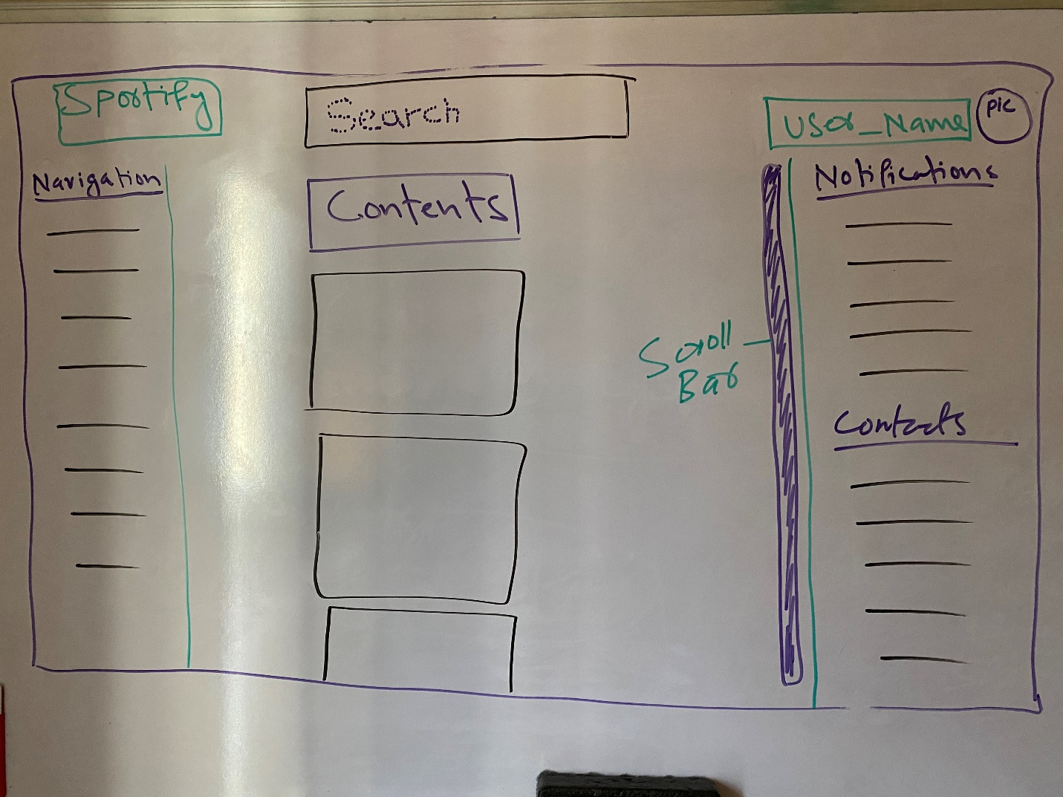

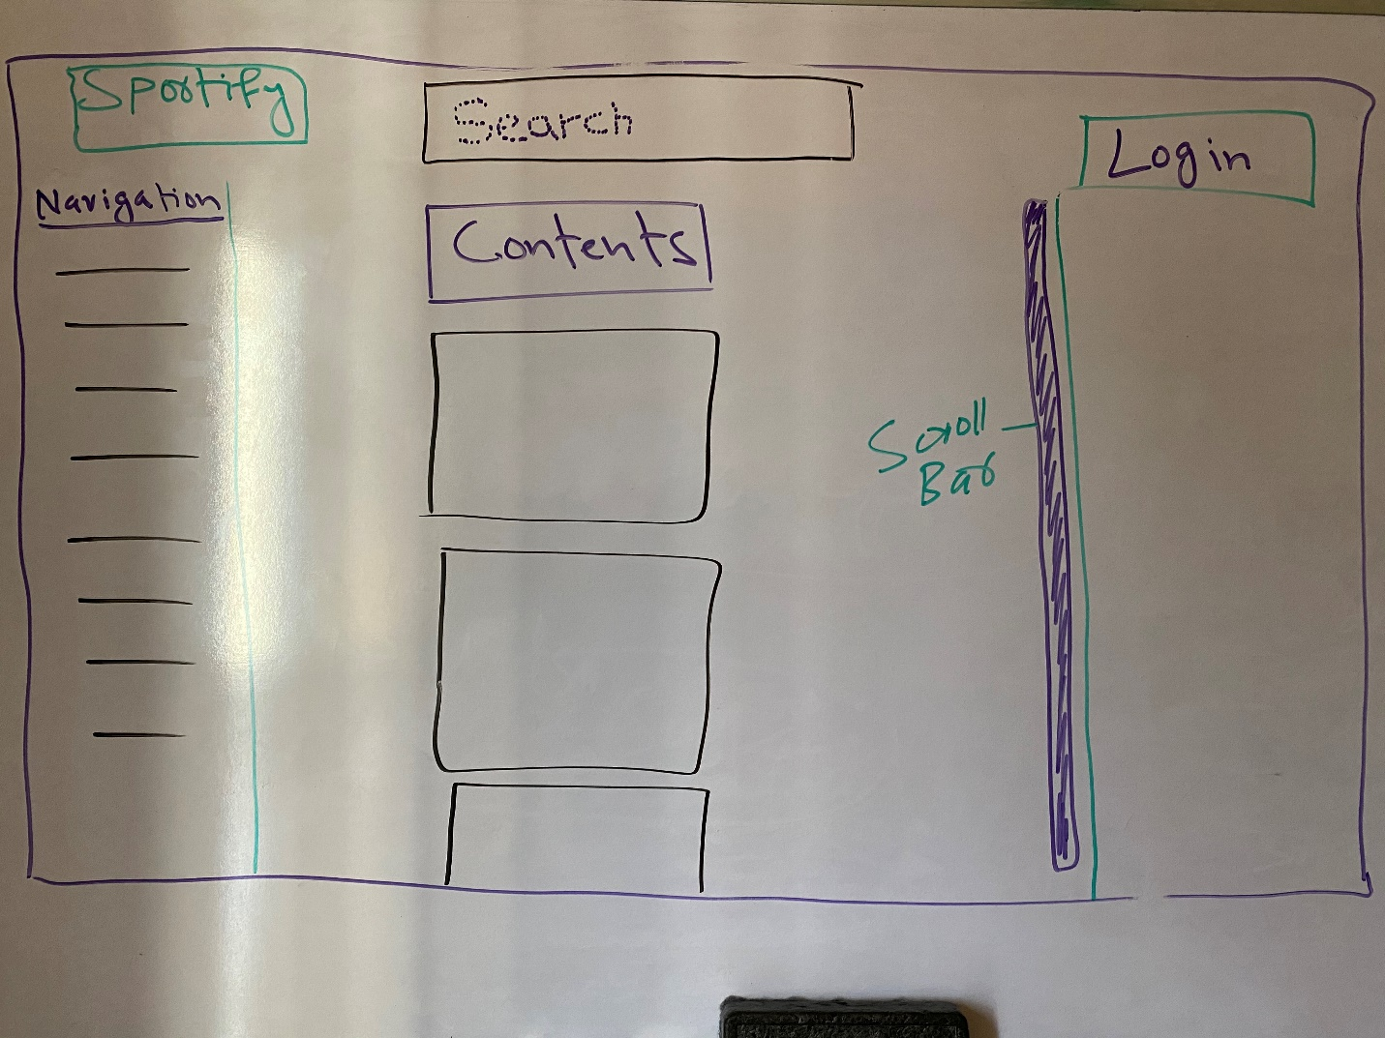

**Search Engine:** This component will be responsible for retrieving data from the database and rendering the most relevant data as per the user’s search query. I will use Python to build the search engine.

**Data Storage and Management:** This component is responsible to sort the data collected from the actions performed by the users and store them in the database. I will use Python and MySQL to build this component.

**Content Management System:** This component determines the choice of contents to be shown on a certain webpage. It will also serve as an easy way to update contents on any webpage. I will use Python and Django framework to build this component.

**Timeline:**

**Repository:**

**URL:** <https://github.com/Muzahir7/CRCP5301>

**Scaling Plan:**

If my timeline gets too tight and I feel like I would not be able complete my project on time, I will consider scaling back of couple of components. I will scrap off some of the features of GUI and Content Management System. Depending on how tight my timeline gets, I will make changes accordingly. At first, I will minus the feature of showing the most related contents to a user based on user’s interests and show something general about sports on their main page. Second cut-off that I will make is going to be the feature that makes content updating on any webpage easy. If I still feel like I cannot complete the project on time, I will minus some of the GUI features like commenting, liking, and sharing posts.

**Documentation and Presentation:**

Since my project is a website and the showcase is going to be on web, I will provide the URL of my published website so that people can interact with the website on their computers. I will accompany my website’s URL with a doc file which explains what the website is about and how people can interact with it.